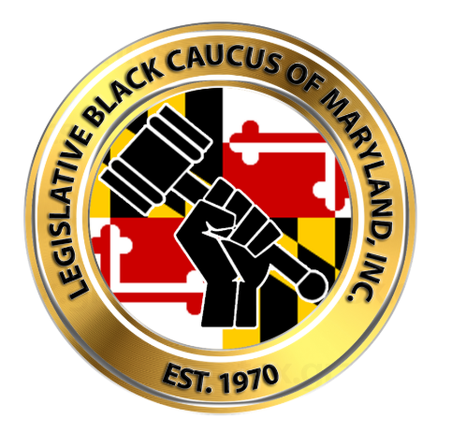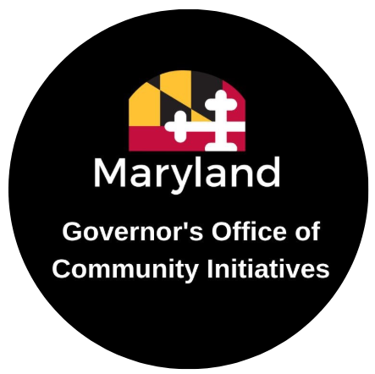 YOUR LOGO
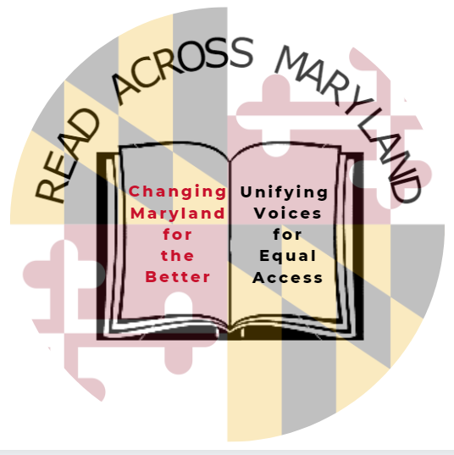

(Your Event Name)
We cordially invite you to (Your Event Name) as part of Read Across Maryland, the annual program launched by the Legislative Black Caucus of Maryland, Inc.
in partnership with the Governor’s Office of Community Initiatives.
Governor Larry Hogan proclaims October as Reading and Financial Literacy Month.

(IMAGES)

Date & Time:
Location:
Contact for Questions and RSVP:
For more info: goci.maryland.gov/ReadAcrossMD.

